|  |  |
| --- | --- |
| Graphical user interface  Description automatically generated with medium confidence  HAzem & Alaa & hossam | Abstract  Examination System to be controlled by more than one user (student, teacher, principal...)  Course  SQL_Project |

1:- instructor determines the date of exam.

create View vExam as select * from Exam

create proc setDateOfExam @start datetime , @end datetime, @nameExam nvarchar(max)

as

begin

declare @idexam int =(select Exam_id from Exam where Exam_name= @nameExam)

update vExam

set Start_time=@start ,end_time=@end

where Exam_id=@idexam

end

exec setDateOfExam '1.1.2233 00:00:00','1.1.1800 00:00:00', 'java';

select * from vExam where Exam_name='java'

2:-instructor determine student to enter the exam and student should be in table of student and table of exam_student.

create view vStudent_exam as select * from Student_Exam;

alter proc determineStudent @startOfStudent int ,@endOfStudent int ,@exm_name nvarchar(max)

as

begin

declare @exam_id int =( select Exam_id from Exam where Exam_name=@exm_name)

declare @conut int = @startOfStudent

while @conut<=@endOfStudent

begin

insert into vStudent_exam(Student_id,Exam_id,degree)

values (@conut,@exam_id,0)

set @conut=@conut+1

end

end

exec determineStudent 1,5,'html'

select * from vStudent_exam

3:- allow instructor to choice question from question text and put it in exam.

alter proc addquestion_from_textquestion_proc @qusexam_id int ,@patren nvarchar

as

begin

declare @x nvarchar(max)=( select Question_descrip from Question_TorF where Question_descrip like '['+@patren +']%')

update Question_Exam

set Question_descrip=@x

where Question_id=@qusexam_id

end

exec addquestion_from_textquestion_proc 4,'how'

select * from Question_Exam

4:- scenario to exam from student number 1 with check his answer.

-- first view for question.

create view exam1 as select Question_descrip from Question_Exam

where Exam_id=1 ;

-- proc fro show question.

create proc show_question

as

begin

select * from exam1

end

-- show question

exec show_question;

--proc to allow student to enter his answer.

alter proc student_ans_true_or_false @answer nvarchar(max) ,@qiestion_id int

as

begin

insert into Student_Answer values(@qiestion_id,1,@answer)

declare @true_answer nvarchar(max)=(select Answer from Question_Exam where Question_id=@qiestion_id)

declare @student_answer nvarchar(max)=(select Student_Answer from Student_Answer where Question_id=@qiestion_id and Student_id=1)

declare @grade int =(select degree from Student_Exam where Student_id=1 and Exam_id=1)

declare @adddegree int

if(@true_answer=@student_answer)

begin

set @adddegree=(select Degree from Question_Exam where Question_id=@qiestion_id)

update Student_Exam

set degree=(@grade+@adddegree)

where Student_id=1 and Exam_id=1

end

else

begin

print 'from esle'

end

end

--student answer:

exec student_ans_true_or_false "true",1

exec student_ans_true_or_false "true",2

exec student_ans_true_or_false "false",3

exec student_ans_true_or_false "true",4

--Show student answer:

select * from Student_Answer;

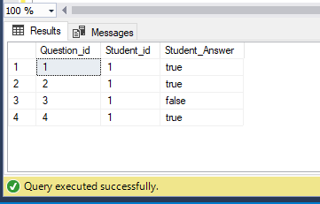

--show student grade

select dbo.show_grade('ahmed');

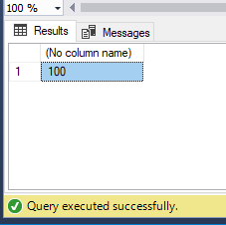

:-this code about determine time of exam to allow student to show question.

alter proc show_question_withTime

as

begin

declare @starttime datetime=(select Start_time from Exam where Exam_id=1)

declare @endtime datetime=(select end_time from Exam where Exam_id=1)

if(@starttime >=GETDATE() AND @endtime <=getdate() )

begin

SELECT Question_descrip FROM exam1

end

else

begin

print 'you are not in day of exam'

end

end

exec show_question_withTime;

allow maneger to add new student

alter procedure manager_add_new_user

@Student_id int,

@F_name nvarchar(max),

@L_name nvarchar(max),

@E_mail nvarchar(max),

@Std_adress nvarchar(max),

@Intake nvarchar(max),

@Track nvarchar(max),

@Phone nvarchar(max),

@pass_word int,

@branch nvarchar(max)

as

begin

insert into Student values(@Student_id ,@F_name,@L_name,

@E_mail,@Std_adress,@Intake,@Track,@Phone,@pass_word,@branch)

End

exec manager_add_new_user 17,'ahmed','matrewy','O.matrewy@gmail.com','Minia',17,'Mobile APP','01019029277' ,123456,'minia'

select *

from Student

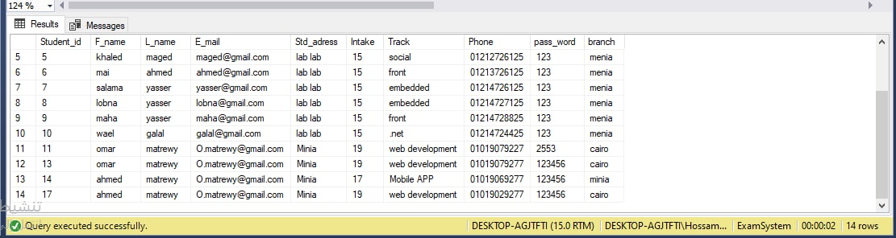

manager update student

alter procedure manager_update_user_data

@Student_id int ,@Intake nvarchar(20), @Track nvarchar(20) , @branch nvarchar(20)

as

begin

update Student

set Intake=@Intake, Track=@Track ,branch=@branch

where Student_id=@Student_id

end

exec manager_update_user_data 17,'19', 'web development' ,'cairo'

select *

from [dbo].[Student]

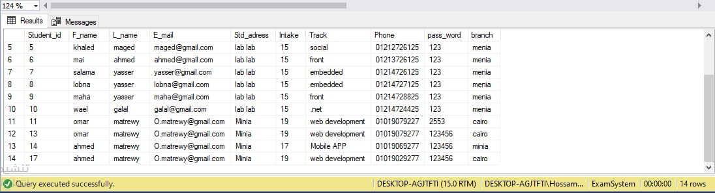

trigger to prevent insert and allow only to manager for question choice

create TRIGGER trg_add_mcq

ON Question_Choice

AFTER INSERT

AS

BEGIN

declare @i int

SELECT @i = inserted.Question_id

FROM inserted;

DELETE FROM Question_Choice WHERE Question_id=@i

AND SUSER_SNAME() != 'DESKTOP-AGJTFTI\Hossam Matrewy'

END

DROP TRIGGER trg_add_mcq

INSERT INTO Question_Choice VALUES(18, 'Question_descripp', 'Option1', 'Option2', 'Option3', 'Option4', 'Answer', 1)

select *

from Question_Choice



trigger to prevent delete and allow only to manager

alter TRIGGER trg_delete_mcq

ON Question_Choice

instead of DELETE

AS

BEGIN

declare @i int

SELECT @i = deleted.Question_id

FROM deleted;

DELETE FROM Question_Choice WHERE Question_id=@i

AND SUSER_SNAME() = 'DESKTOP-AGJTFTI\Hossam Matrewy'

END

DROP TRIGGER trg_add_mcq

DELETE FROM Question_Choice where Question_id=18

select *

from Question_Choice

